**Key points covered:**

* Can go through this doc to have a flow like experience of code & following things are implemented:
* API implemented
* Authentication and authorization. Jwt, PassportJS, password, encrypt to save password in db
* Frontend (ejs views)
* Database and design
* Express Concepts (Middleware, Routes etc.)
* Role implemented.
* header with navigation, footer & logout button
* code structuring: views, middleware, controllers, model, routers, role etc
* MongoDB over cloud

**Login Screen**

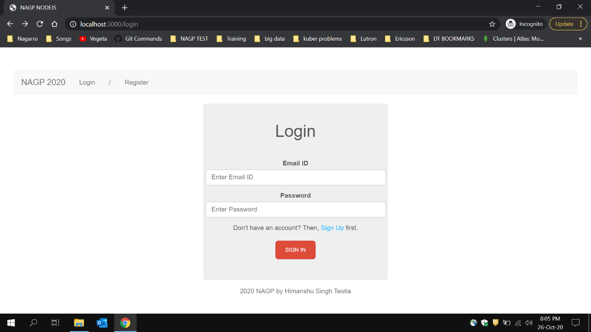

**Login Screen empty fields submission**

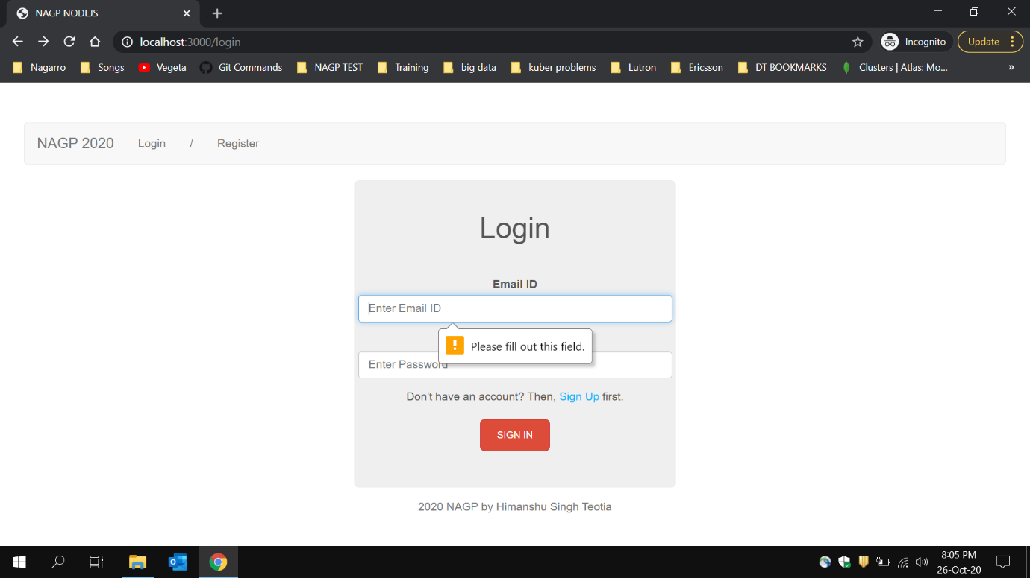

**Register Screen**

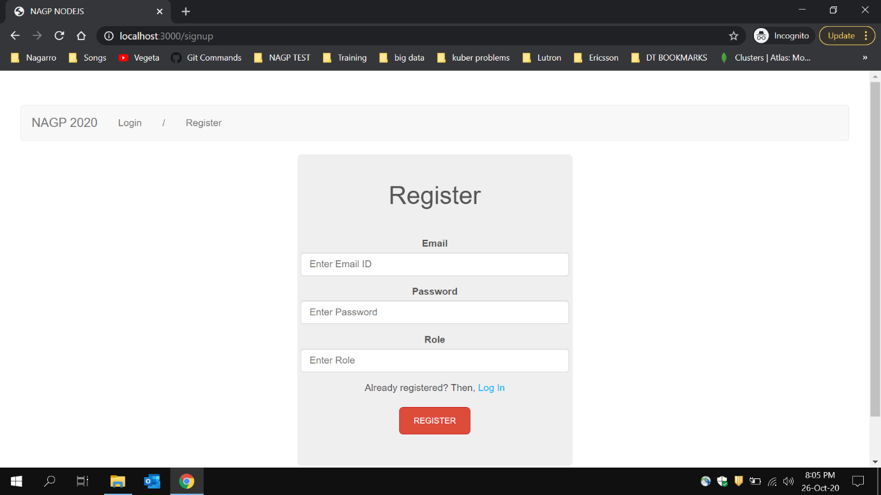

**Register Screen empty fields submission**

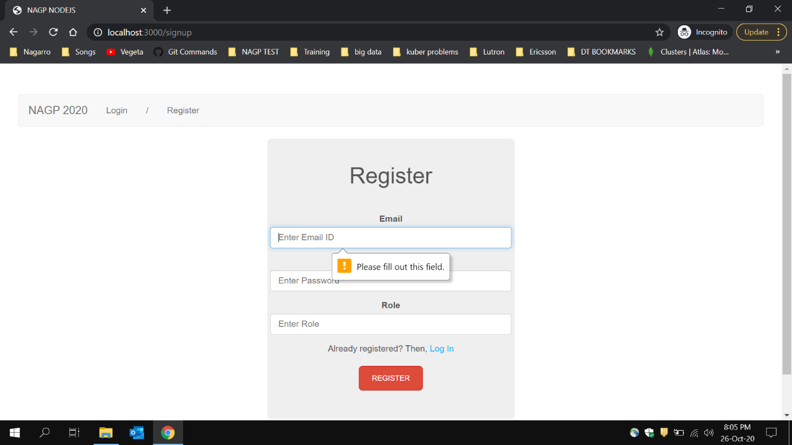

**New Registration:**

**Email:** [**admin@gmail.com**](mailto:admin@gmail.com)

**Password: admin**

**Role: manager**

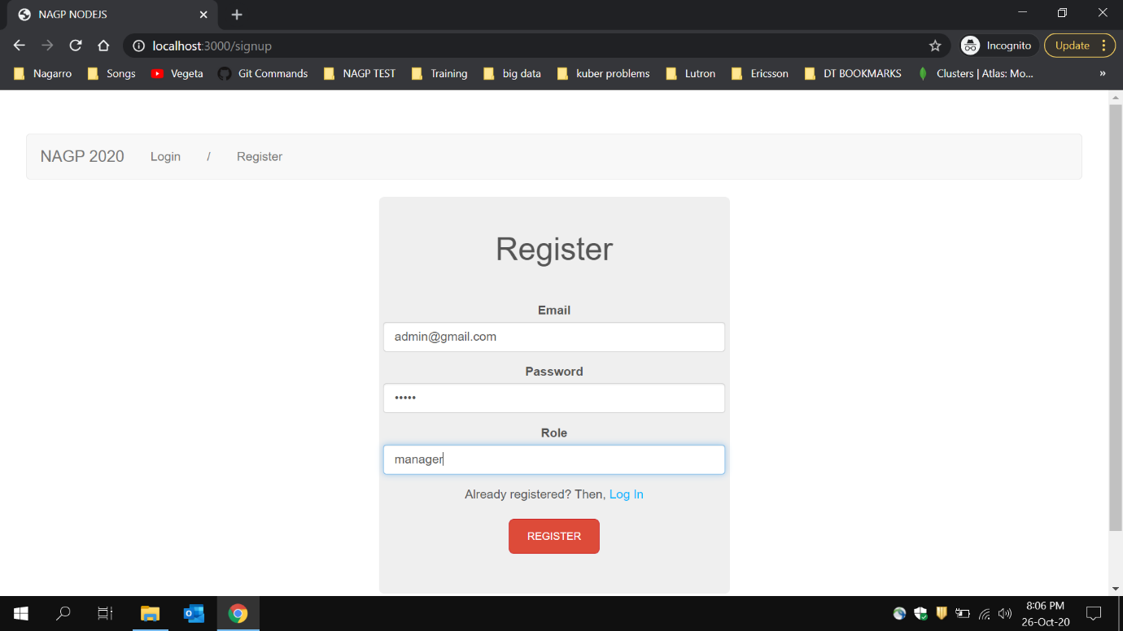

**Trying to login with wrong email id**

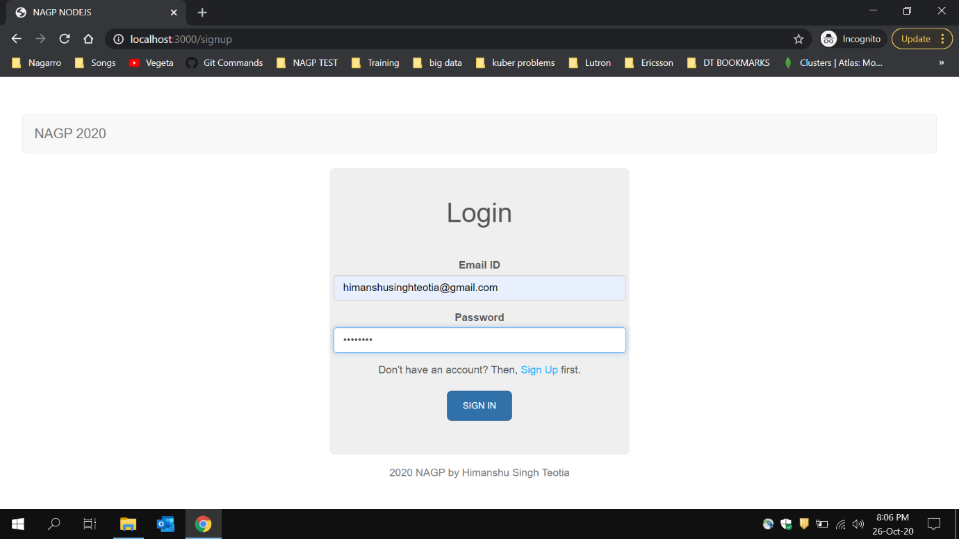

**Wrong credentials result**

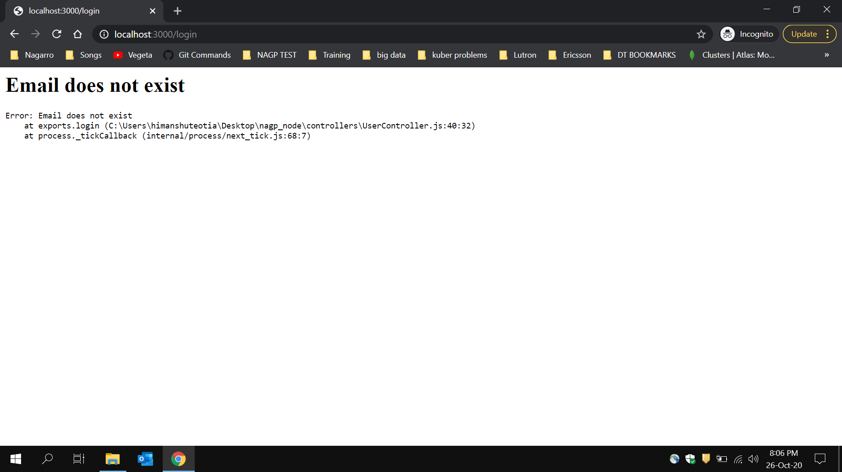

**Trying with wrong password but correct email id**

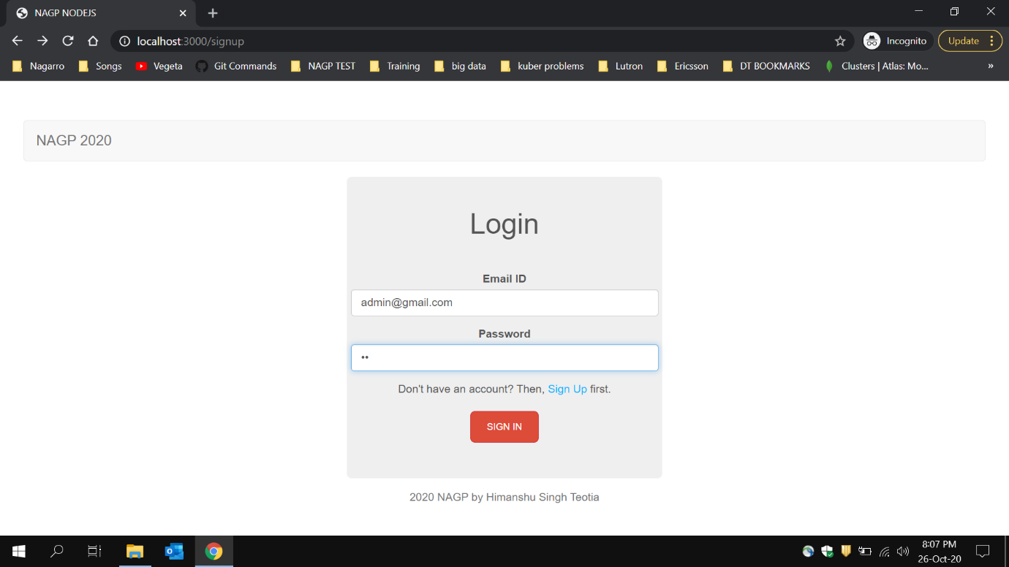

**Result of wrong password**

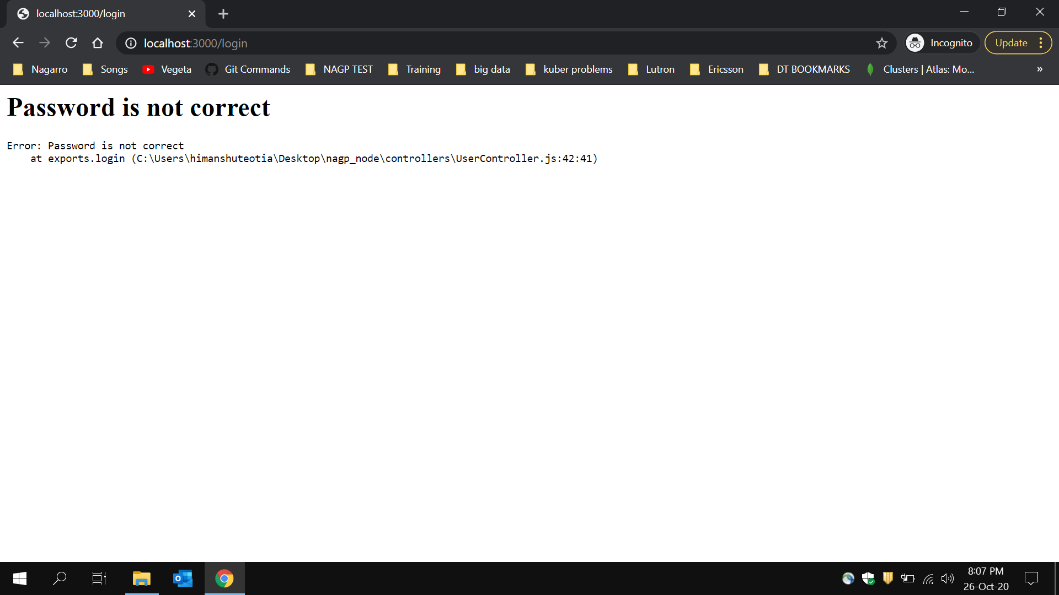

**Login with correct credentials**

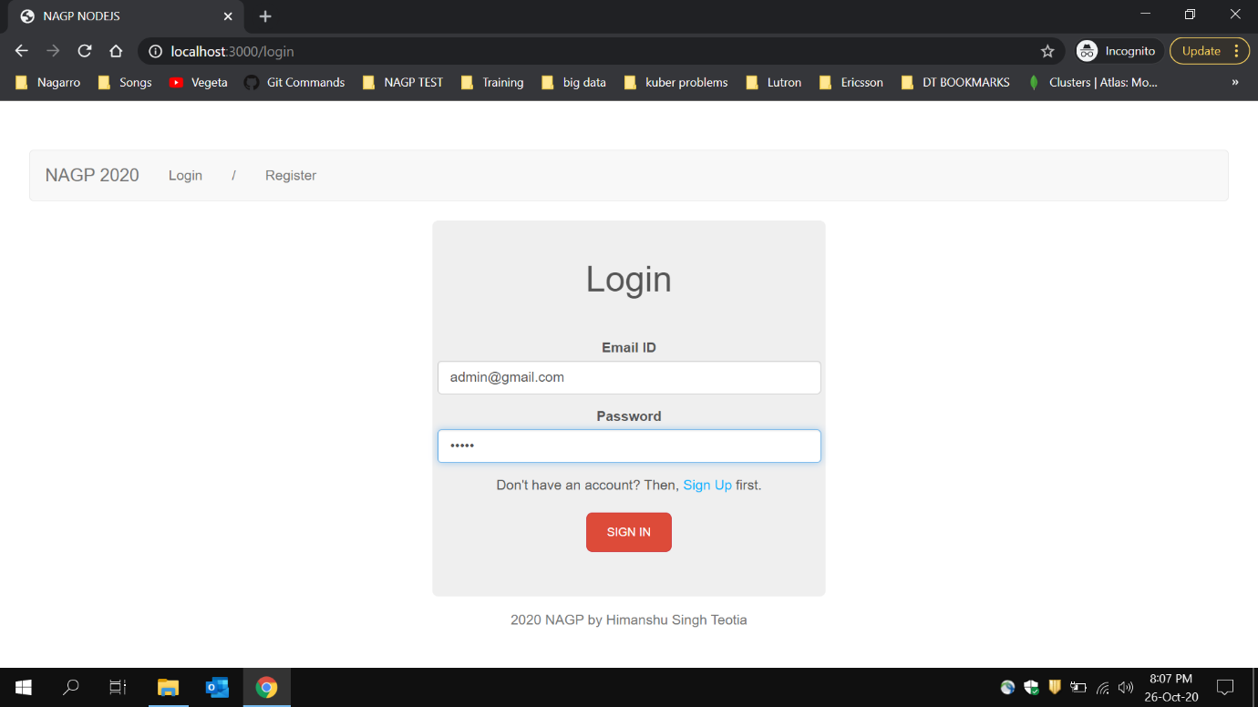

**First time successful login as a manager**

**Login/Register : hidden**

**Log out and other links shown**

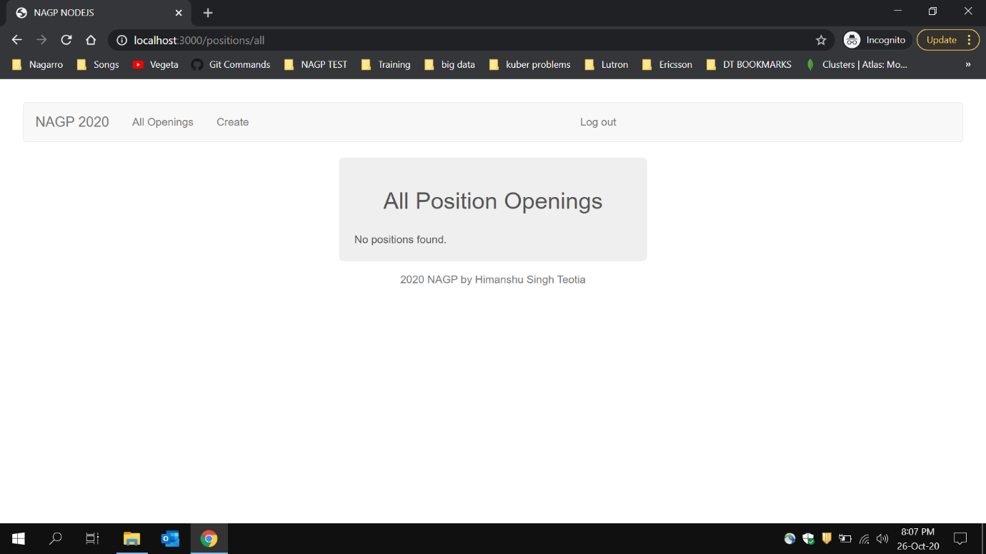

**Creating position(only manager)**

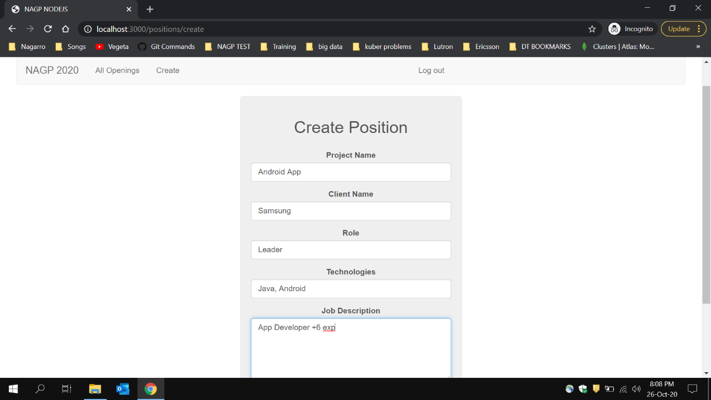

**Position created**

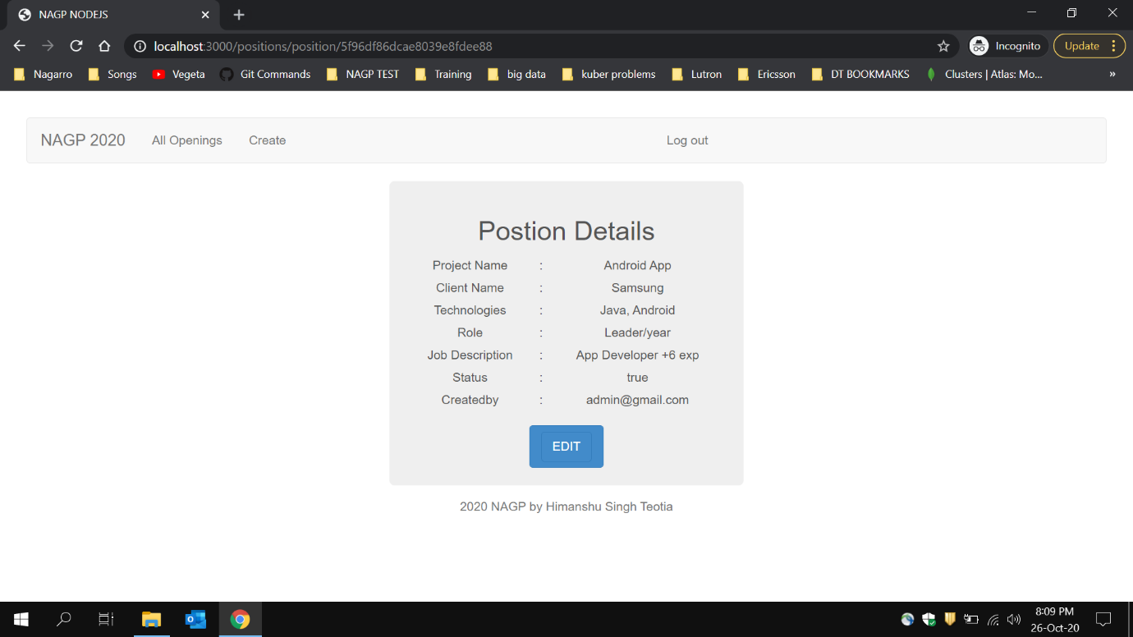

**Empty filed while creating postion**

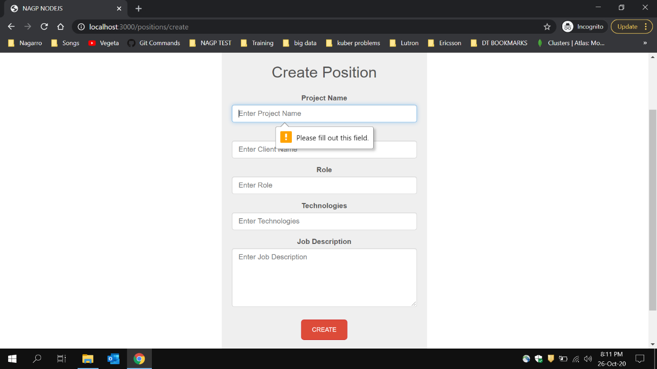

**After creating some more positions**

**Can see hyperlinks over project name to see its details**

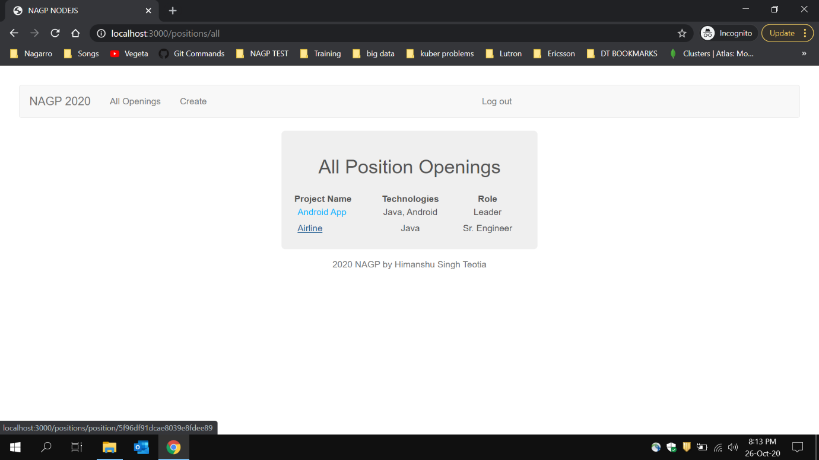

**Position details of clicked project name**

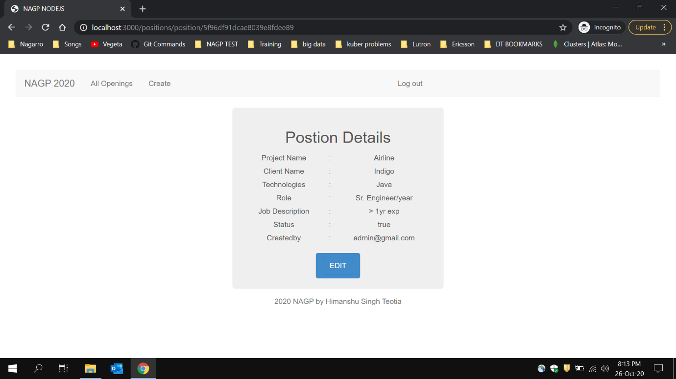

**Hover over Edit button to update**

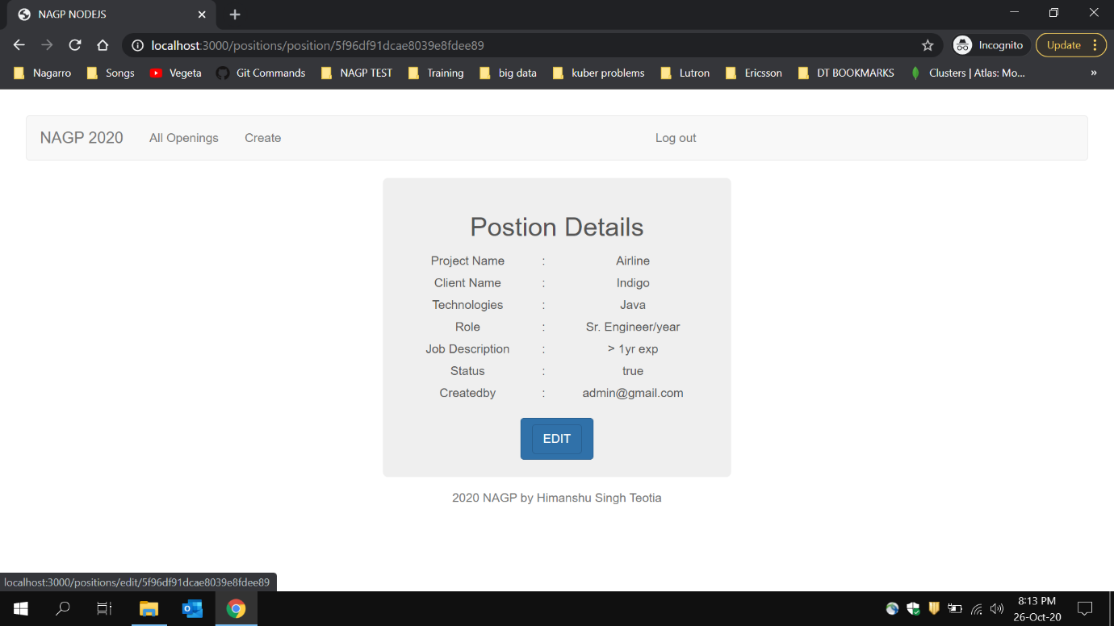

**Updating details in position**

**From Java to Java & NodeJS**

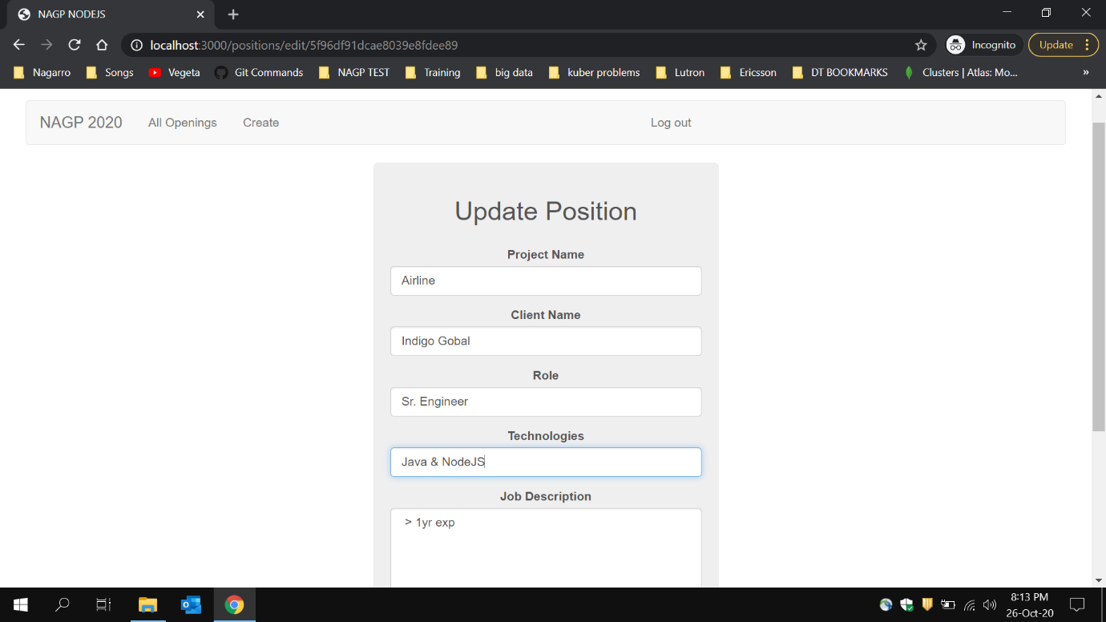

**Result after update**

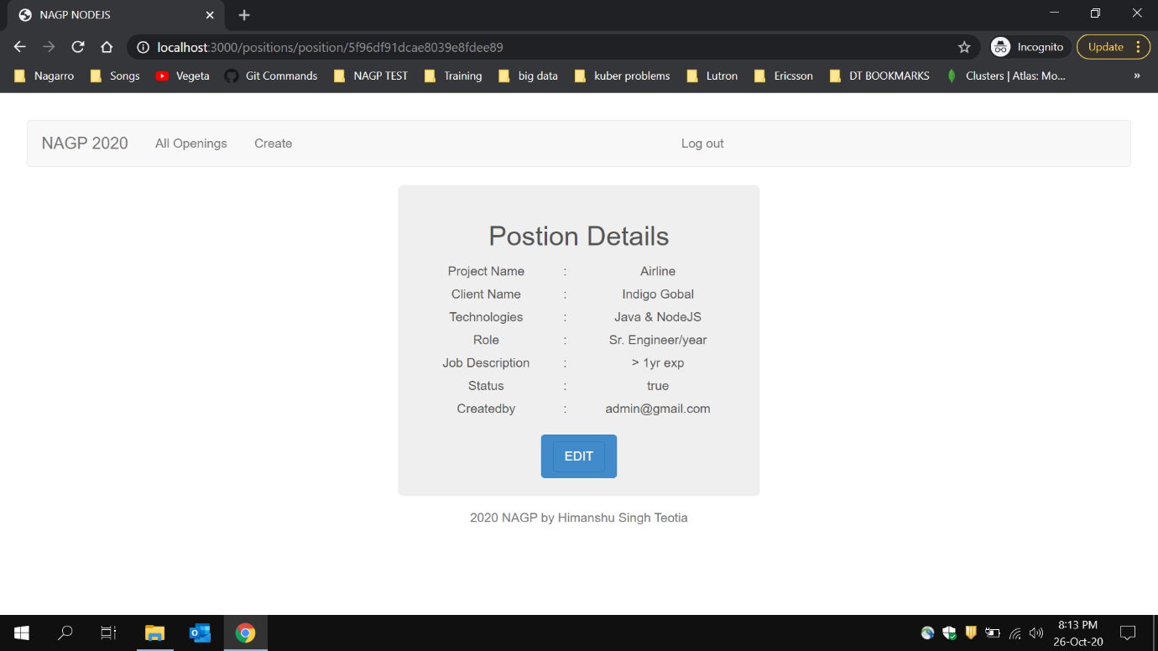

**Positions after update**

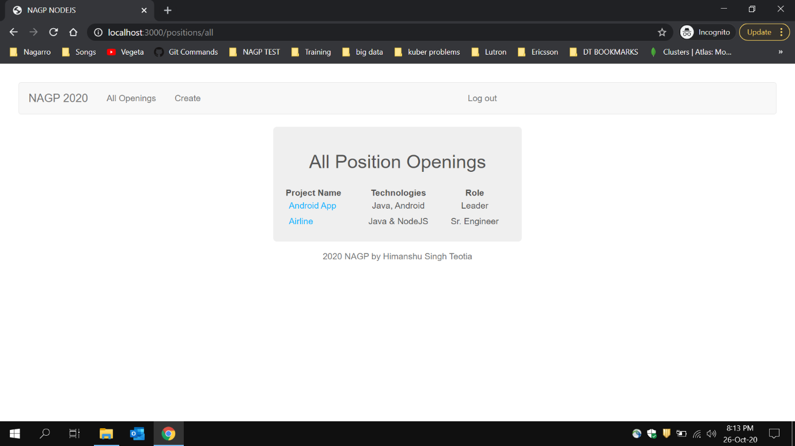

**Added some more positions**

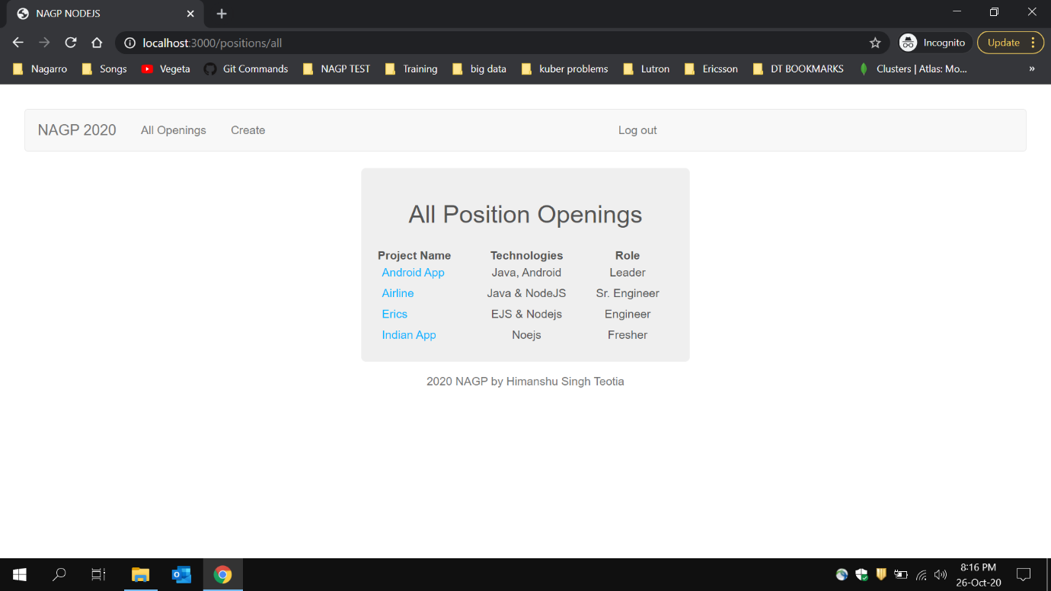

**Clicking on logout**

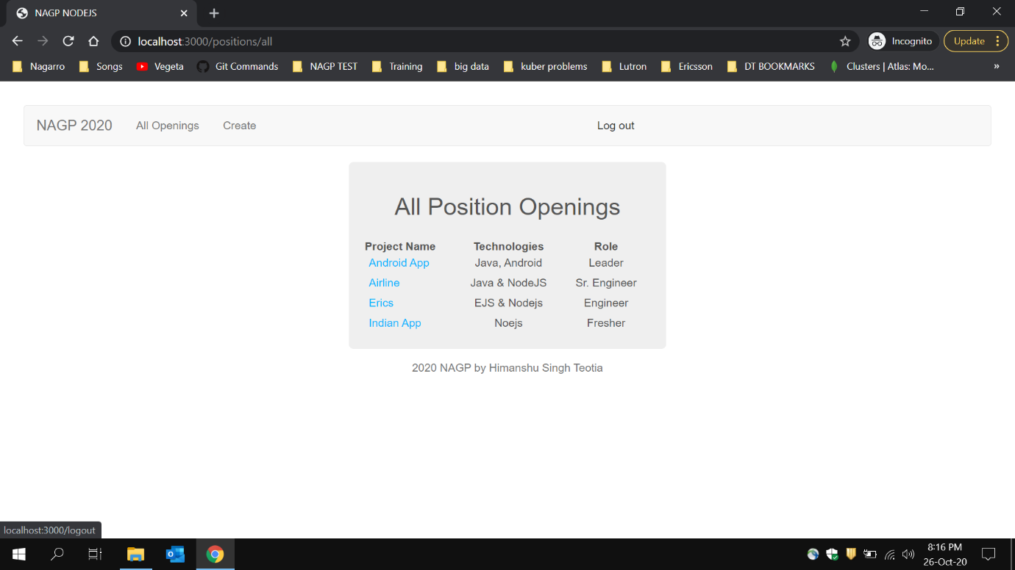

**Result after logout**

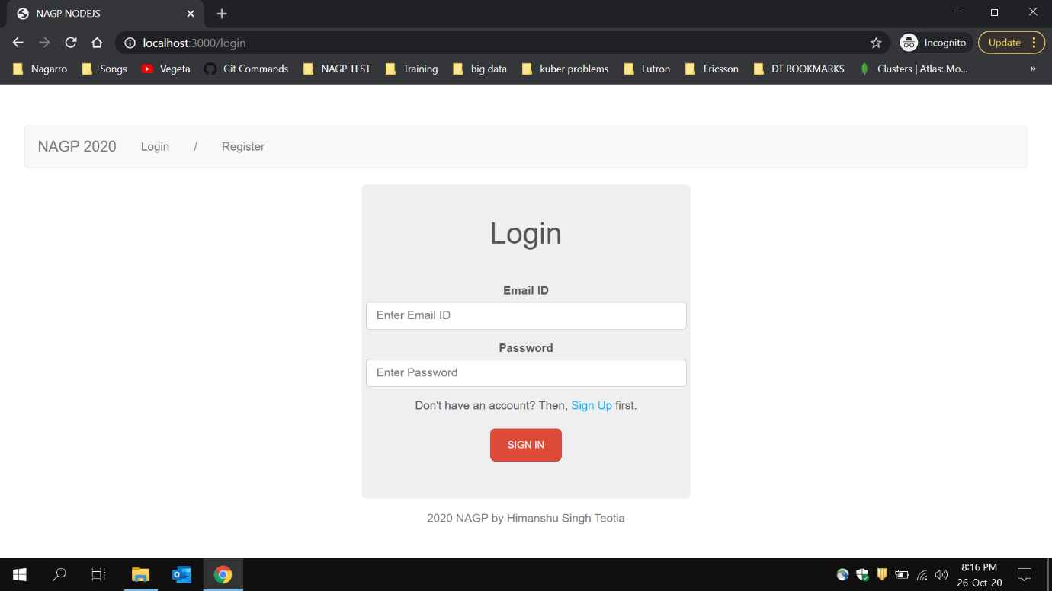

**New registration for employee**

**Email :** [**himanshu@gmail.com**](mailto:himanshu@gmail.com)

**Password: him**

**Role: employee**

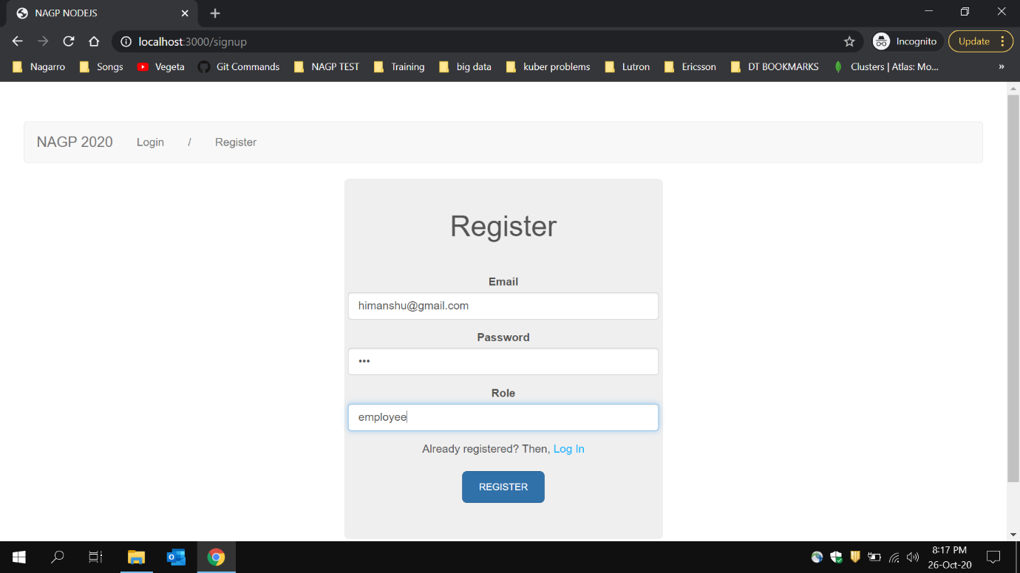

**Login with new credentials as employee**

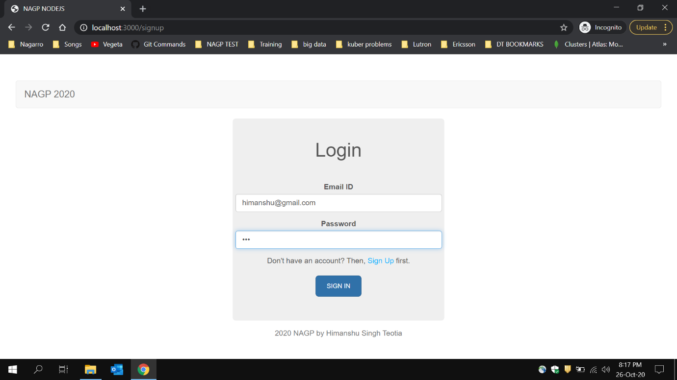

**Positions opening for employee**

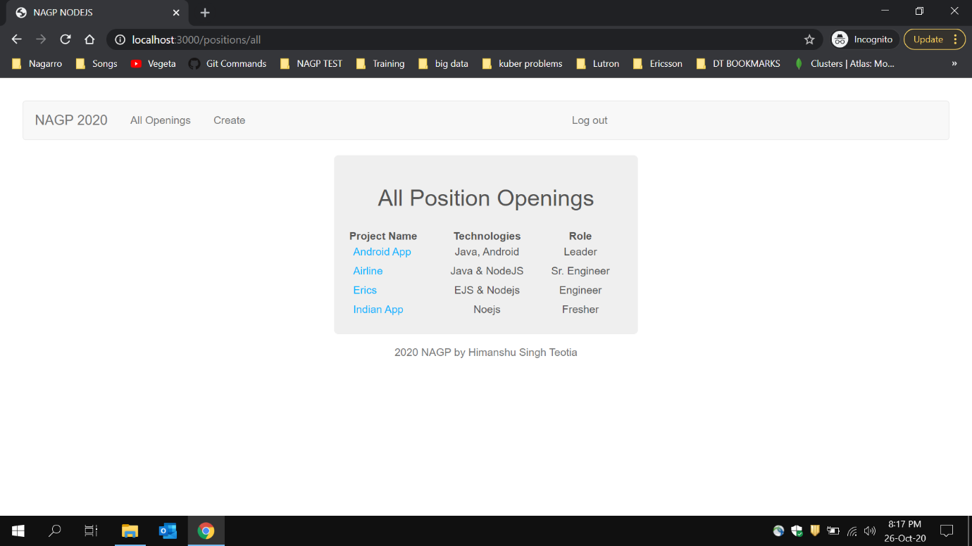

**Position Details from employee role**

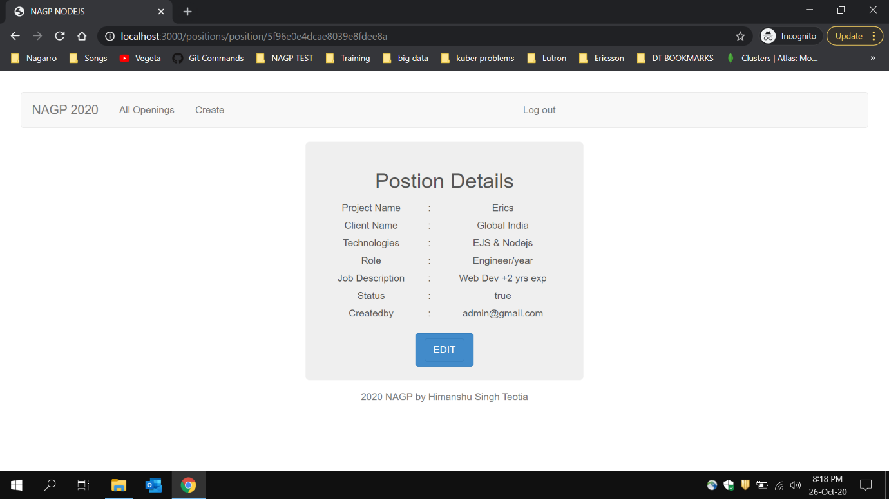

**Employee Cannot access Edit position after tried**

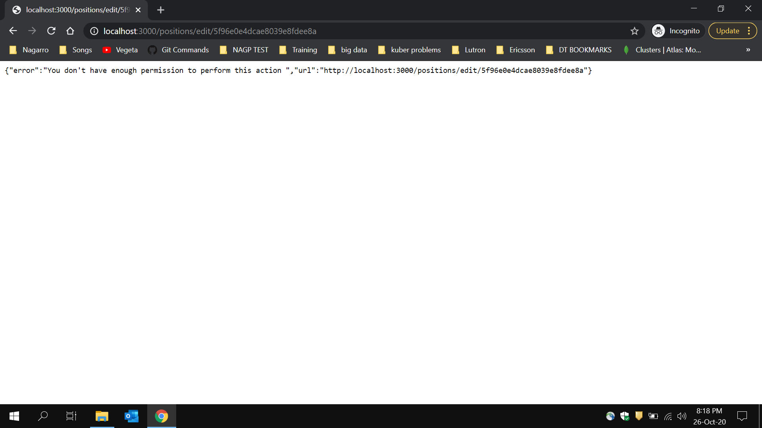

**Employee role cannot create new position**

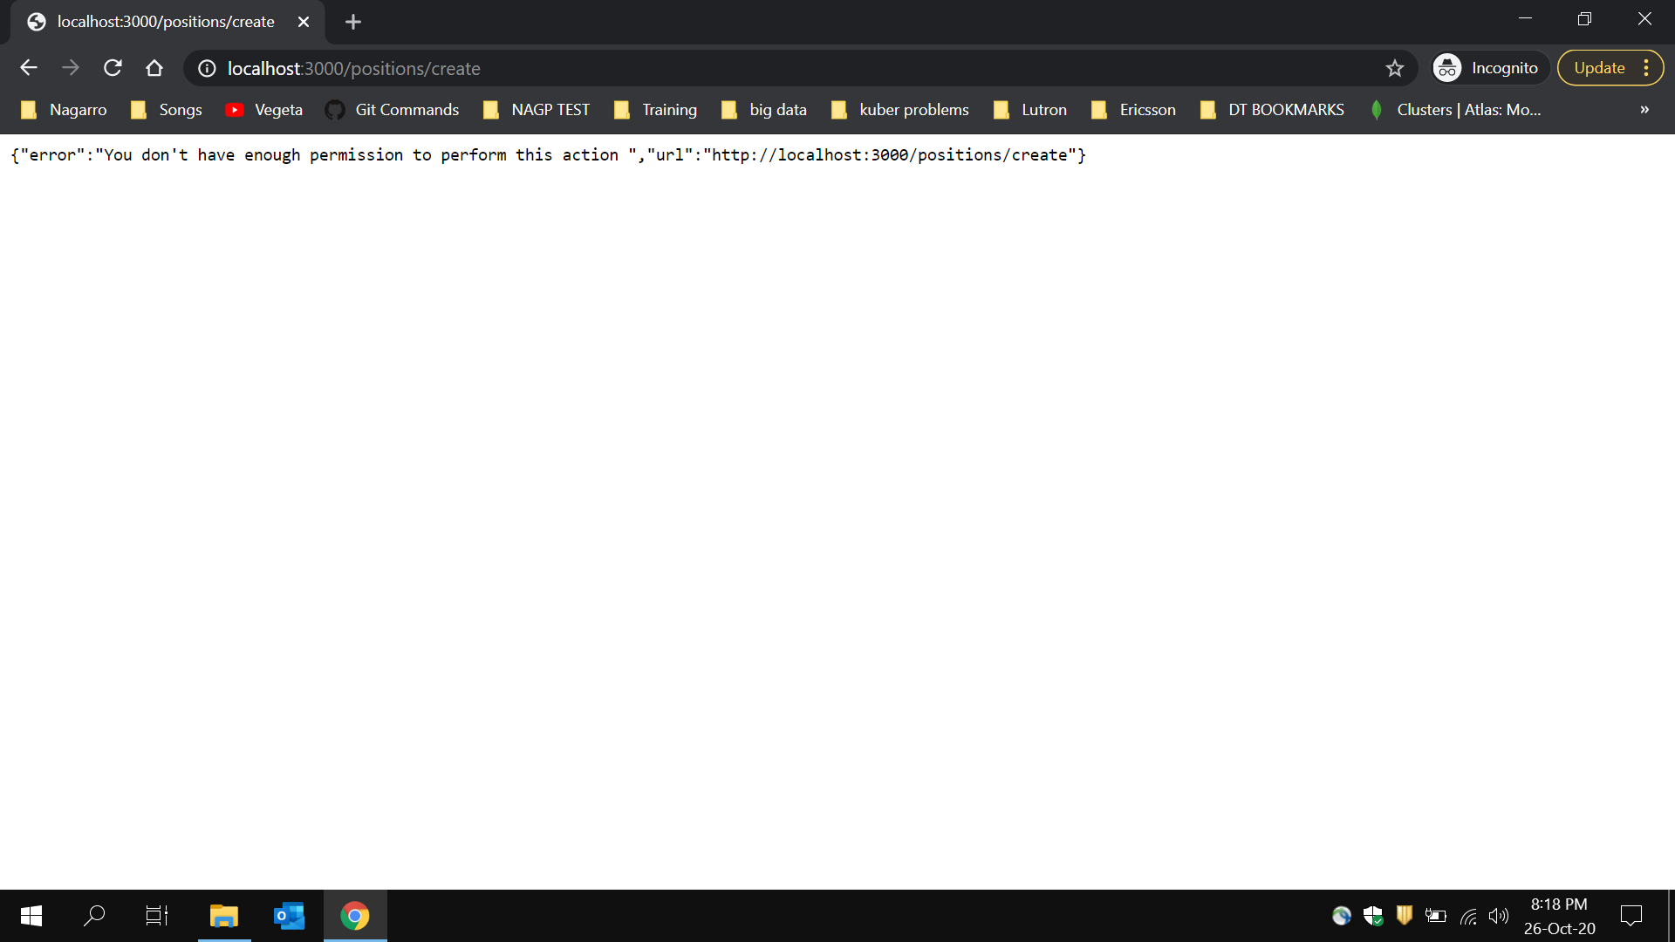

**Clicking over logout(check the hover link)**

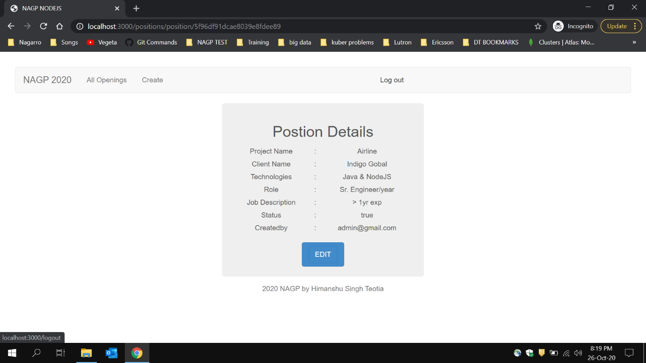

**Login page after logout and required changes in navigation**

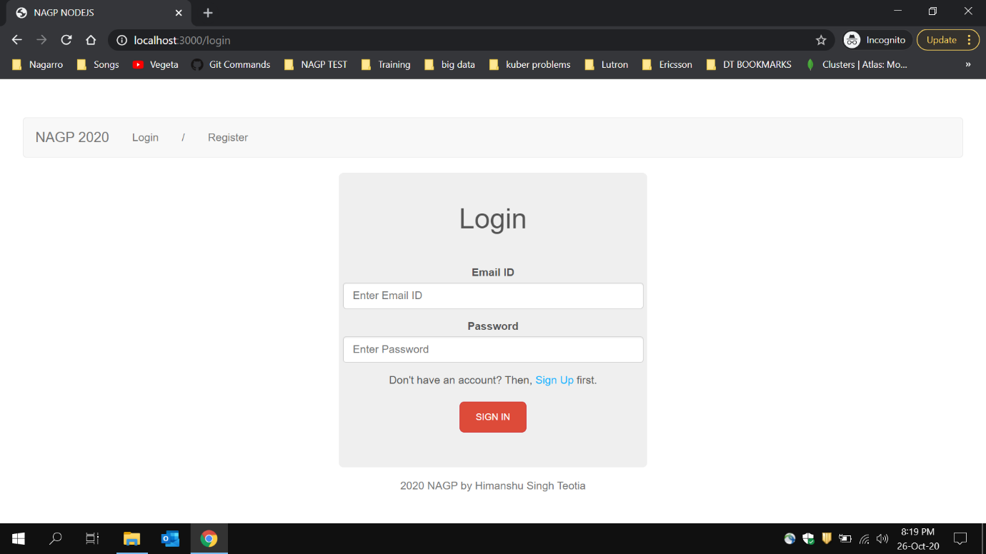

**Trying to see position through URL without login**

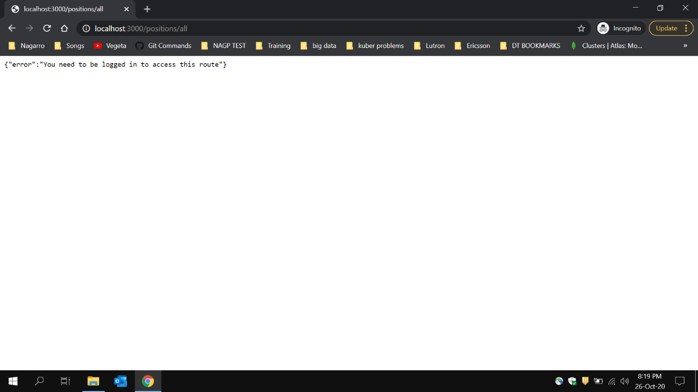

**Trying to access create link with login**

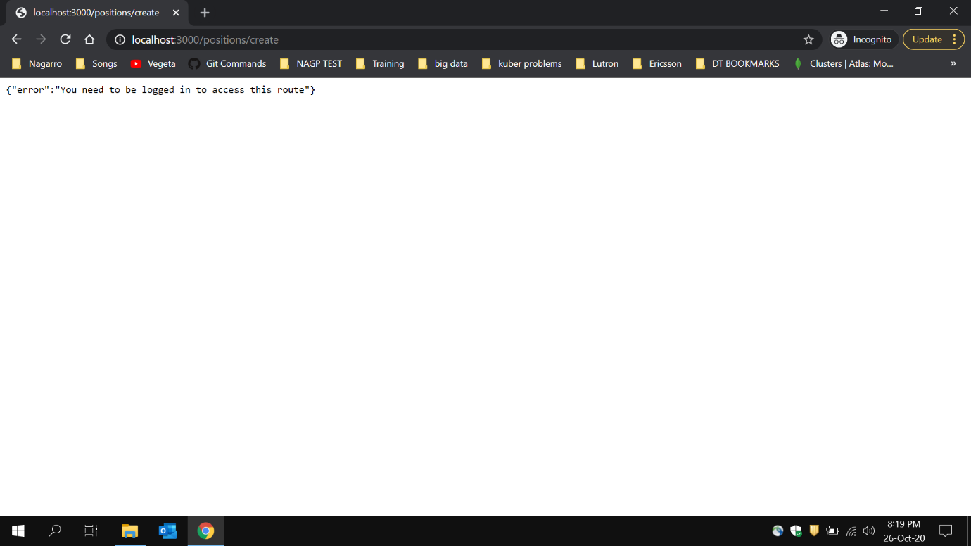

**Trying to see position details without login**

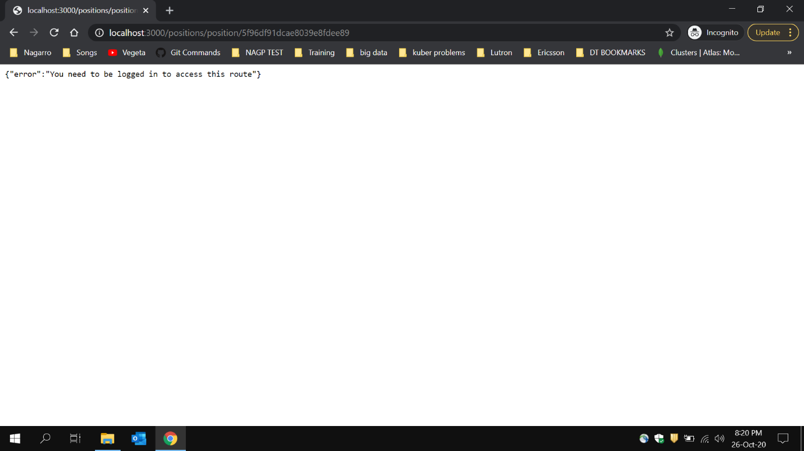

**Trying to update position without login**

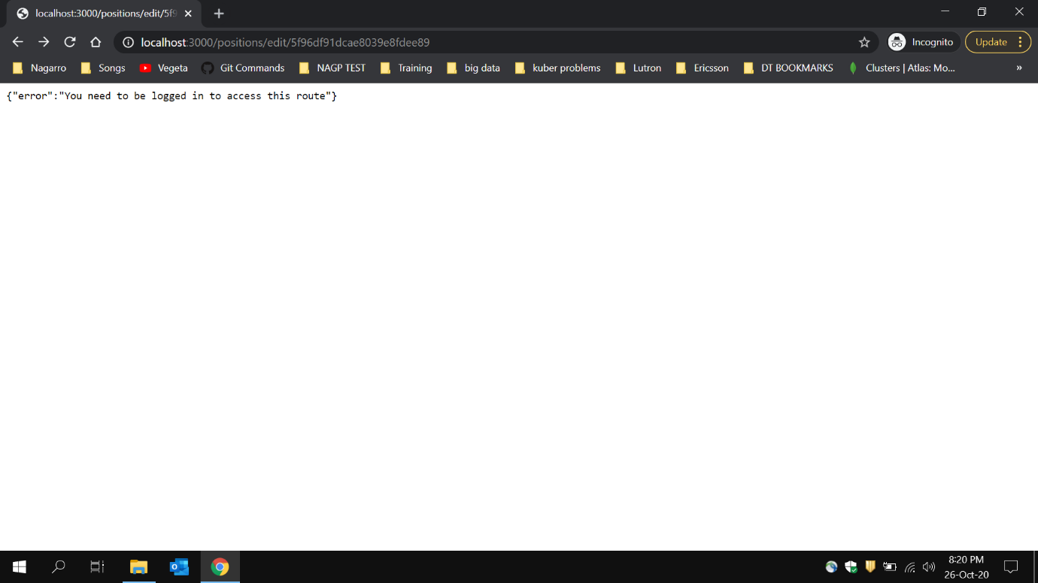

**NOTE: SCREENSHOT CONTAINS LOCAL DB**

**BUT IN CODE that is SHARED HAVE THE CLUSTER DB OVER CLOUD**

**Values in Mongo DB in users table**

**Schema:**

**role, email, password(encrypted), accessToken**

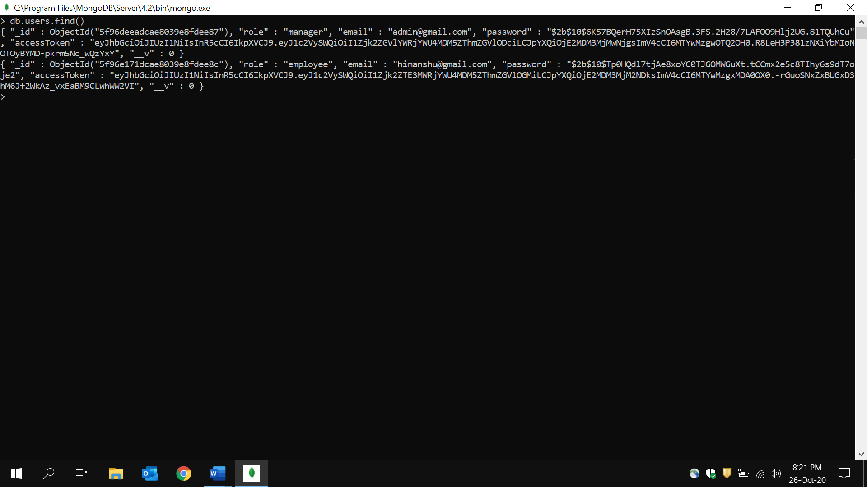

**Values in Mongo DB in positions table**

**Schema:**

**technologies, projectName, clientName, role, jobDescription, status, created by**

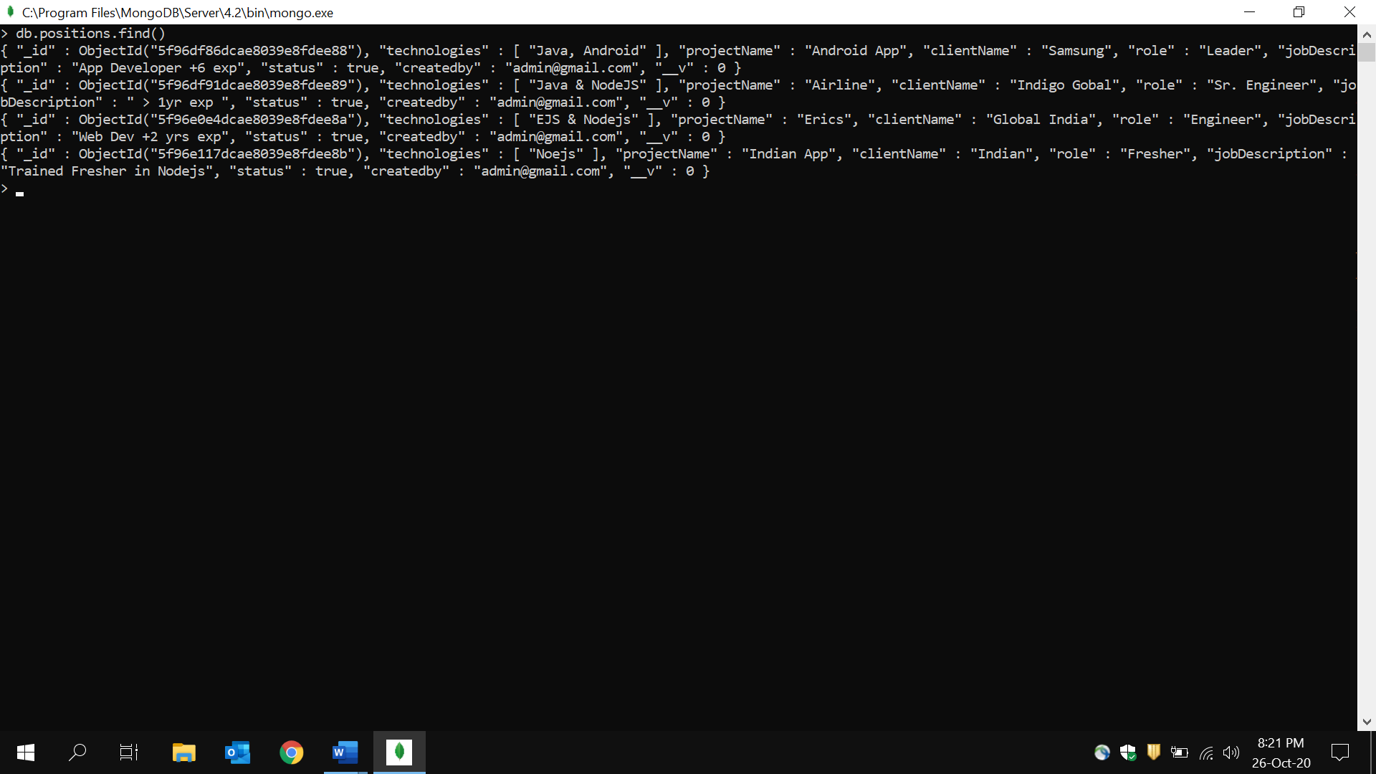

**Trying to register the same email id**

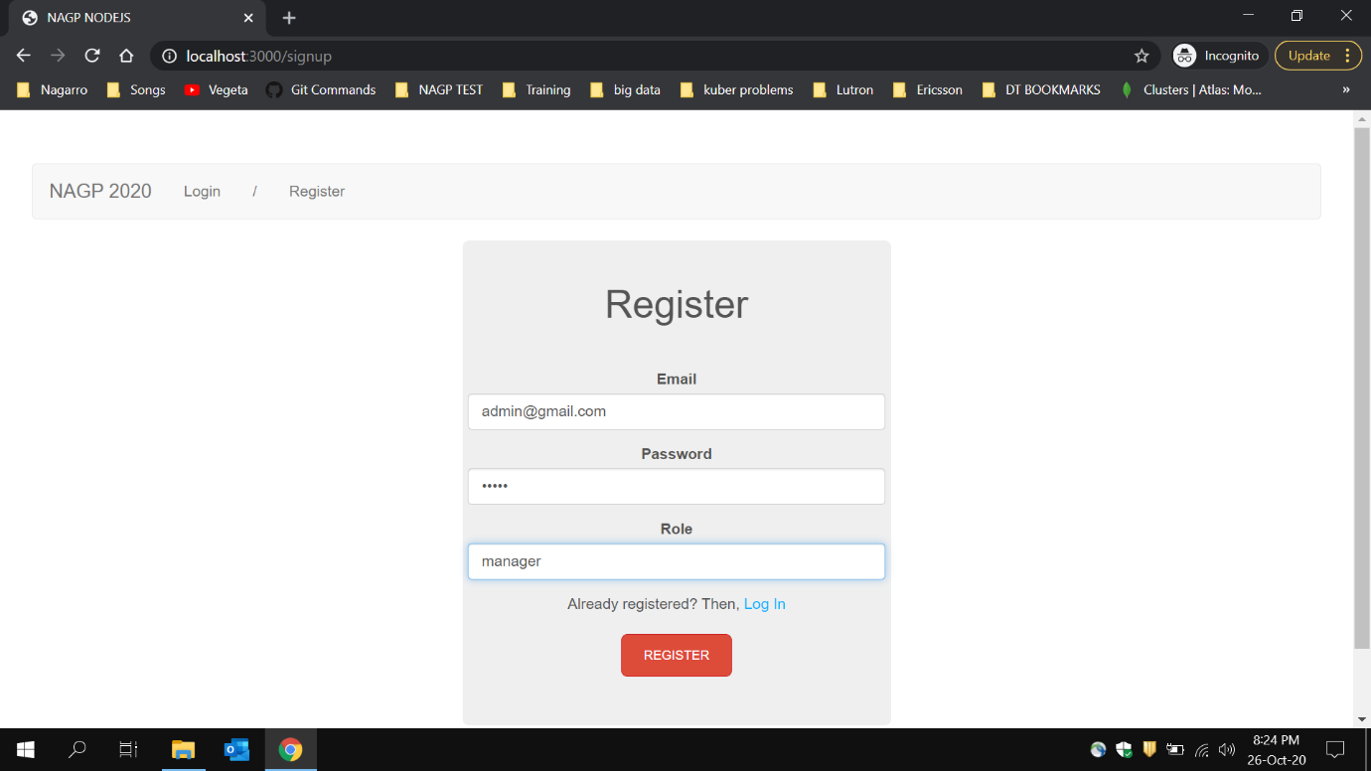

**Result after trying to create new user which already exists.**

